

**9**

**Science**

**Learning Activity Sheets**

Quarter 1: Week 5

**ORGANIC REACTION MECHANISMS**

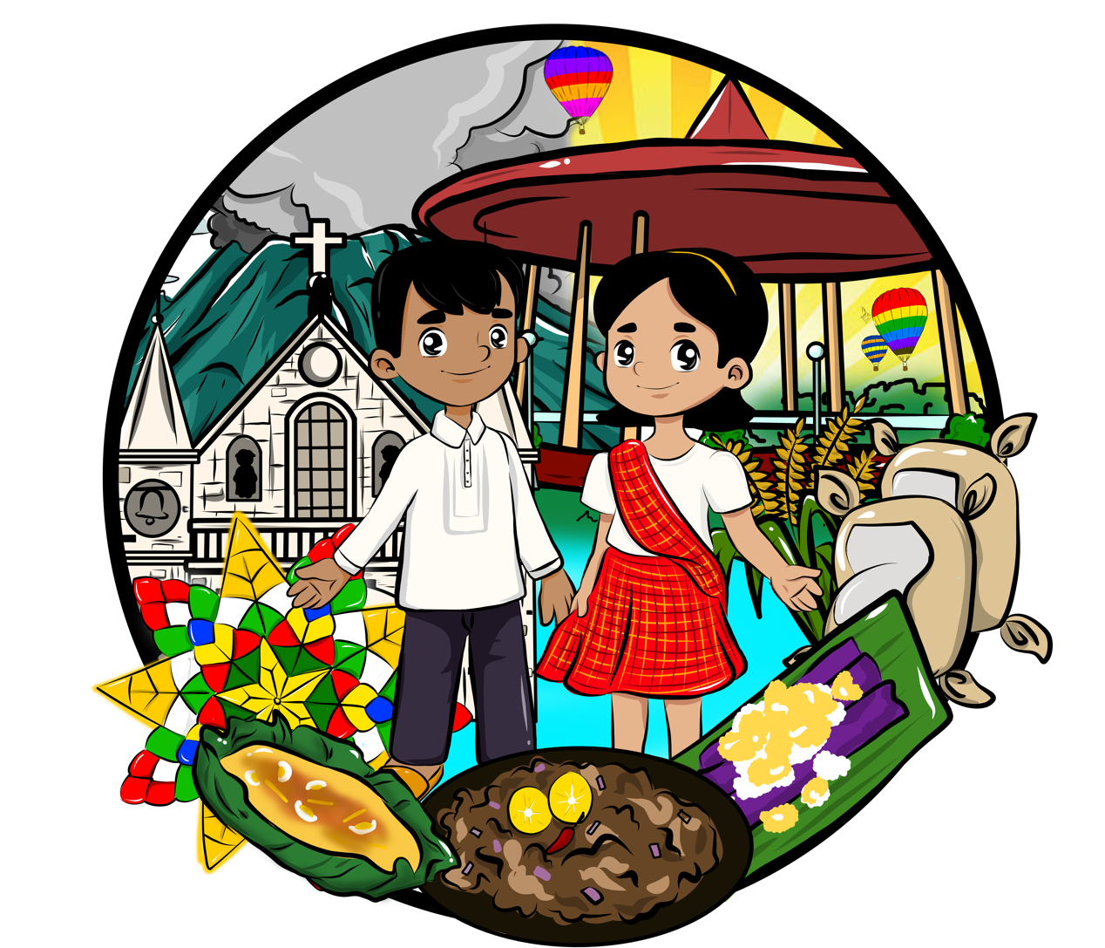

**CONSUMER CHEMISTRY-STE 9**

Name: _Paul Gerald D. Pare___________________________ Date: _11/5/20________

Section: _9 - Adenine_____________________________________ Q1W5

**ORGANIC REACTION MECHANISMS**

**Background Information**

Organic reactions involve the chemical reactions among organic compounds. The reaction of given organic compounds may involve one of three fundamental classes of reactions. In some cases, a reaction proceeds spontaneously on mere contact with reactants, but more frequently catalysts are required to bring it about.

**Learning Competency**

Describe the chemical reactions involving organic compounds

* Addition
* Elimination
* Polymerization

**A. Reaction Mechanism**

Every reaction involves the breaking of existing bonds in the reactants and the formation of new bonds in the products. The sequence of bond-breaking and bond-forming processes may occur in several types or they may occur in one synchronous step. The series of steps which describe the transformation of the reactants into products are called the **reaction mechanisms.**

An overall picture of a reaction mechanism may be illustrated as follows:

**Substrate + Reagent [Transition State]**

**Product Reaction Intermediate**

where:

**Substrate** – the organic compound that undergoes a particular kind of reaction

**Reagent** – the substance which acts upon the substrate to bring about a reaction

**Transition state** – the state of bond-breaking and bond-forming processes

**Reaction Intermediate** – the unstable but reactive specie produced from the transition state after a bond is broken

Example:

A general reaction mechanism for the chlorination of ethane,

uv

CH3CH3 + Cl2 CH3CH2Cl + HCl

is shown below:

bond-forming

bond-breaking

CH3CH2 ..H+ Cl2 [ CH3CH2. .H. .Cl]

[ CH3CH2. + HCl]

.Cl

CH3CH2Cl + HCl

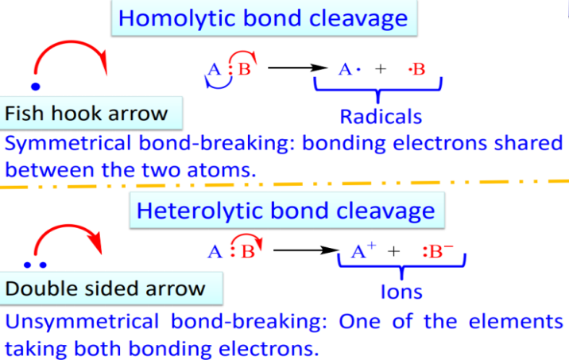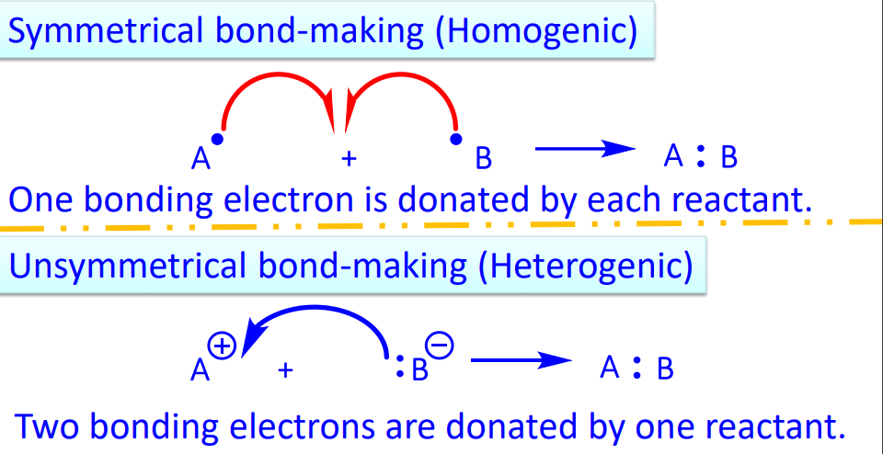

**Free Radical Reactions**

* Reactions that involve symmetrical bond- breaking ***(hemolytic)*** and bond-making ***(homogenic)***
* Atoms or group of atoms with odd number of electrons
* Free radicals cannot all be paired
* Species are highly reactive

**Polar Reactions**

* Reactions that involve unsymmetrical bond- breaking ***(heterolytic)*** and bond-making ***(heterogenic)***
* The most common reaction among organic compounds
* Occur between negatively charged ***(anions)*** and positively charged ***(cations)*** ions

**B. REACTION INTERMEDIATES AND ITS STABILITY**

There are three known reactions intermediates which are formed when single covalent bonds are cleaved or broken. The fragments resulting from bond cleavage processes are highly reactive and ordinarily react very rapidly with other molecules in their environment. Under these circumstances, reaction intermediates are more transitory species in the progress of a reaction from reactants to products.

1. **Alkyl Free Radical**

An alkyl free radical is a species that contains an unpaired electron. It is formed when a covalent bond between two atoms breaks in such a manner that each of the initially bonded atoms retains one of the electrons in the bond. Such kind of bond breaking is called **homolytic cleavage (symmetrical)**

CH3 .. X CH3 . + . X

Alkyl free radicals are classified as primary, secondary or tertiary according to the number of carbon atoms attached to the carbon bearing the unpaired electron.

.

10 CH3CH2 ethyl radical

.

20 CH3CHCH3 isopropyl radical

.

30 CH3CCH3 tert-butyl radical

CH3

Free radicals are stabilized by groups that donate electrons to the trivalent carbon radical. Alkyl groups are better at releasing electrons than are hydrogen substituents. The more the alkyl groups that are attached to the carbon radical, the more stable the radical. Thus, the order of free radical stability and ease of formation are:

**Tertiary > Secondary > Primary**

1. **Carbocation or carbonium ion**

A ***carbocation or carbonium ion*** is a species that contains a positively charged carbon. It is formed when a covalent bond breaks in such a manner that the pair of electrons leave with the departing atom. This kind of bond breaking is called **heterolytic cleavage (unsymmetrical)**

CH3 : X CH3 + + : X -

Carbocations are classified as primary, secondary or tertiary according to the number of carbons that are attached to the positively charged carbon.

+

10 CH3CH2 ethyl carbocation

+

20 CH3CHCH3 isopropyl carbocation

+

30 CH3CCH3 tert-butyl carbocation

CH3

Carbocations, like free radicals, are stabilized by substituents, such as alkyl groups, that release electrons to the positively charged carbon. Thus, the order of carbocation stability and ease of formation parallel that of free radicals:

**Tertiary > Secondary > Primary**

1. **Carbanion**

A carbanion is a species that contains negatively charged carbon. It is formed when a hydrogen atom in an organic compound is removed as a proton by a strong Lewis base, leaving a pair of electrons to the carbon atom.

CH3 : H + :B :CH3 - + B : H

Carbanions do not follow the same order of stability as that of the carbocations and free radicals due to the unshared pair of electrons on them. The stability of carbanions depend on the strength of the base,:B and the structural features that contribute to the stability of the ion.

**C. ISOMERS**

**Isomers** are different compounds that have the same molecular formulas. The isomers are distinct chemical individual; therefore, they have different chemical and physical properties.

1. **Structural isomers** are isomers that differ in the order in which their atoms are connected. Structural isomers may be further classified into three types:
2. **Chain isomers** are isomers of molecules whose carbon atoms are connected in straight chains or branched chains.

Example:

C5H12 CH3CH2CH2CH2CH3 pentane

CH3CHCH2CH3 2-methylbutane

CH3

1. **Positional isomers** are isomers of molecules having the same functional group. The functional group is attached at nonequivalent positions in the carbon structure.

Example:

C3H8OCH3CH2CH2OH 1-propanol

CH3CHCH3 2-propanol

OH

1. **Functional isomers** are isomers of molecules having different functional groups.

Example:

C3H6OCH3CH2CHO propanal

CH3COCH3 acetone

1. **Stereoisomers** are isomers that have the same structure but differ in the arrangement of their atoms in space.

Example:

H

H

C2H2Cl2 C = C cis-1,2-dichloroethene

Cl

Cl

Cl

H

C2H2Cl2 C = C trans-1,2-dichloroethene

H

Cl

**Activity 1- Getting to Know Stage**

**Direction:** Identify the terms describe on each statement below. Write your answer on the space provided. Refer to the pool of terms below.

_Carbocation_______1. It is a species that contains a positively charged carbon.

Reaction Mechanisms 2. These are the series of steps which describe the transformation of the reactants into products.

_Transition States ___3. This is the state of bond-breaking and bond-forming processes.

_Stereoisomers_____4. These are isomers that have the same structure but differ in the arrangement of their atoms in space.

_Structural/Constitutional Isomers 5. These are isomers that differ in the order in which their atoms are connected.

_Free Radicals______6. It is a species that contains an unpaired electron.

_Symmetrical Bond Breaking 7. Other term for homolytic bond cleavage

_Unsymmetrical Bond Breaking_8. Other term for heterolytic bond cleavage

_Secondary carbon __9. Classification of carbon with two carbons attached to it.

_Tertiary carbon_____10. Classification of carbon with three carbons attached to it.

**Symmetrical Transition state**

**Tertiary Stereoisomers**

**Reaction mechanisms Free radicals**

**Structural isomers Unsymmetrical**

**Carbocations Secondary**

**Activity 2: Truth or Lie**

**Directions:** Write **TRUTH** if the statement is correct. If the statement is incorrect, underline the word/s that make the statement wrong and write the correct word that will replace to make it correct. Write your answer on the space provided.

_Truth _________1. Tertiary carbocations and free radicals are more stable and more reactive than the primary one.

_Unsymmetrical__2. Symmetrical bond-breaking and bond-making involve positively and negatively charged ions.

_Homolytic______3. Heterolytic bond cleavage and homogenic bond-making form free radicals.

_Truth__________4. Carbonians are negatively charged carbons.

_Free radical___ _5. Polar reactions contain atoms or group of atoms with odd number of electrons.

_Same_ ____6. Isomers are different compounds with same molecular formula and same physical and chemical properties.

_Truth__________7. Homolytic bond cleavage involves electrons shared between two atoms.

_Heterogenic____ 8. Homogenic bond-making involves two bonding electrons shared by one reactant.

_Polar__________9. Free radical reactions involve formation of ions.

_Free Radicals_ _10. Carbanions have the same stability rules with carbocations.

**Activity 3: You Fill Me Up!**

**Direction:** Fill in the missing spaces on the table below with the correct term, reactant or product.

|  |  |  |  |
| --- | --- | --- | --- |
| **Bond Cleavage/Bond Making Type** | **Reactants** | **Products** | **Free Radical/ Polar Reactions** |
| Homolytic Bond Cleavage | **A : B** | **A . + . B** | **Free Radical Reactions** |
| Heterolytic Bond Cleavage | **A : B** | **A+ + B-** | **Polar Reactions** |
| Homogenic Bond Making | **A . + . B** | **A : B** | **Free Radical Reactions** |
| Heterogenic Bond Making | **A+ + B‑** | **A : B** | **Polar Reactions** |

**Activity 4: Are we Isomers?**

**Directions:** Encircle the letter of the pairs of structural isomers.

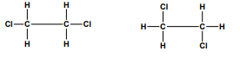

**A.**



**B.**

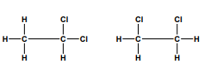

**C.**

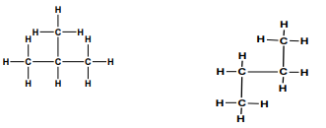

**D.**

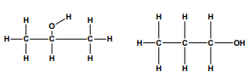

**E.**

**Activity 5: Are you Isomers?**

Examine each of the following pairs of chemical structures and decide if they are identical, isomers or different compounds.

|  |  |  |  |
| --- | --- | --- | --- |
|  | **Chemical Structure 1** | **Chemical Structure 2** | **Identical / Isomers / Different Compounds** |
| **1** |  |  | **Identical** |
| **2** |  |  | **Isomers** |
| **3** |  |  | **Identical** |
| **4** |  |  | **Isomers** |
| **5** |  |  | **Identical** |
| **6** |  |  | **Isomers** |
| **7** |  |  | **Isomers** |
| **8** |  |  | **Different Compounds** |
| **9** |  |  | **Isomers** |
| **10** |  |  | **Different Compounds** |

**Reflection:**

1. What are the two (2) activities that you have enjoyed most? Why?

_________________________________________________________________________

_________________________________________________________________________

_________________________________________________________________________

2. What are the activities that you will not forget?

_________________________________________________________________________

_________________________________________________________________________

_________________________________________________________________________

**References:**

<https://www.researchgate.net/publication/335396038_ADVANCED_ORGANIC_CHEMISTRY_-I_MPC_102T_UNIT-I_Basic_Aspects_of_Organic_Chemistry_Types_of_Reaction_Mechanisms_and_Methods_of_Determining_Them>

<https://profiles.uonbi.ac.ke/sderese/files/h-sch_102__types_of_organic_reactions_and_mechanisms.pdf>

**ANSWER KEY**

|  |  |  |
| --- | --- | --- |
| **Activity 1**   1. Carbocation 2. Reaction Mechanisms 3. Transition state 4. Stereoisomers 5. Structural isomers 6. Alkyl Free radicals/ Free radicals 7. Symmetrical bond-breaking 8. Unsymmetrical bond-breaking 9. Secondary carbon 10. Tertiary carbon | Activity 2   1. Truth 2. (Symmetrical) Unsymmetrical 3. (Heterolytic) Homolytic 4. Truth 5. (Polar) Free radical 6. (same) Different 7. Truth 8. (Homogenic) Heterogenic 9. (Free Radical) Polar 10. (Carbanions) Free radical |  |
| |  |  |  |  | | --- | --- | --- | --- | | **Bond Cleavage/Bond Making Type** | **Reactants** | **Products** | **Free Radical/ Polar Reactions** | | Homolytic Bond Cleavage | **A : B** | **A . + . B** | **Free Radical Reactions** | | Heterolytic Bond Cleavage | **A : B** | **A+ + : B -** | **Polar Reactions** | | Homogenic Bond Making | **A . + . B** | **A : B** | **Free Radical Reactions** | | Heterogenic Bond Making | **A+ + : B -** | **A : B** | **Polar Reactions** | | | |

**Encircle the letter of the pairs of structural isomers.**



**A.**



**B.**



**C.**



**D.**



**E.**

Examine each of the following pairs of chemical structures and decide if they are identical, isomers or different compounds.

|  |  |  |  |
| --- | --- | --- | --- |
|  | **Chemical Structure 1** | **Chemical Structure 2** | **Identical / Isomers / Different Compounds** |
| **1** |  |  | **Identical** |
| **2** |  |  | **Isomers** |
| **3** |  |  | **Identical** |
| **4** |  |  | **Isomers** |
| **5** |  |  | **Identical** |
| **6** |  |  | **Isomers** |
| **7** |  |  | **Isomers** |
| **8** |  |  | **Different compounds** |
| **9** |  |  | **Isomers** |
| **10** |  |  | **Different compounds** |